Experiment 1: FIND-S Algorithm

Aim
To implement the FIND-S algorithm to determine the most specific hypothesis consistent with the given training examples.

Procedure
- Read the training dataset.
- Initialize the hypothesis with the first positive example.
- Compare the hypothesis with every positive training example.
- Generalize attributes wherever differences occur.
- Display the final hypothesis.

Program
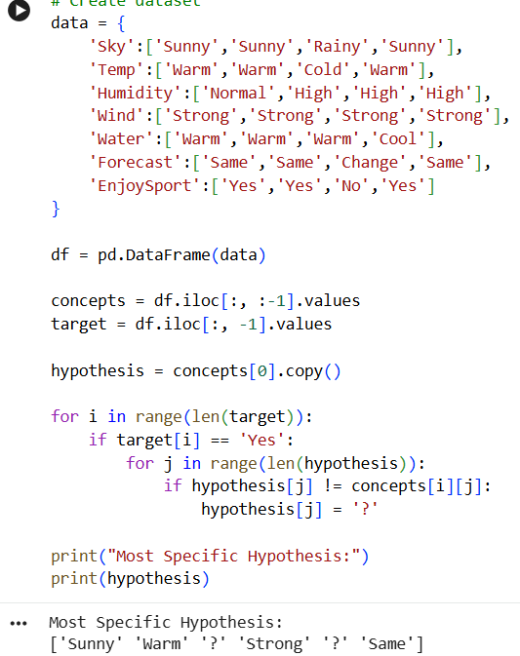

Result
The most specific hypothesis consistent with all positive examples was obtained successfully.

Experiment 2: Candidate Elimination Algorithm

Aim
To implement Candidate Elimination Algorithm to determine the version space.

Procedure
- Read dataset.
- Initialize S and G.
- Update S for positive examples.
- Update G for negative examples.
- Display final S and G.

Result
Candidate Elimination algorithm successfully produced the Specific and General hypothese

Program
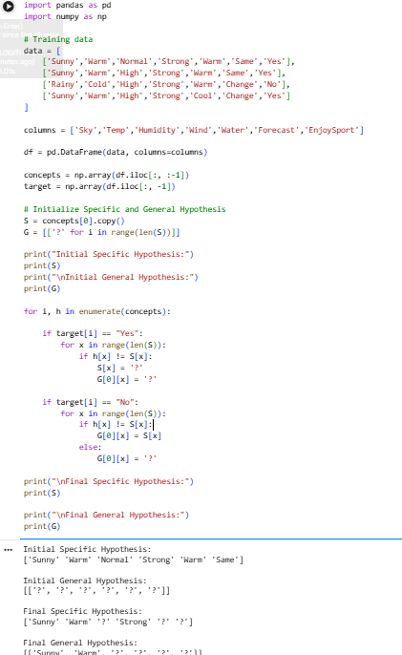

Experiment 3: ID3 Decision Tree

Aim
To implement ID3 Decision Tree algorithm.

Procedure
- Load dataset.
- Encode categorical values.
- Train Decision Tree.
- Predict new sample.

Program

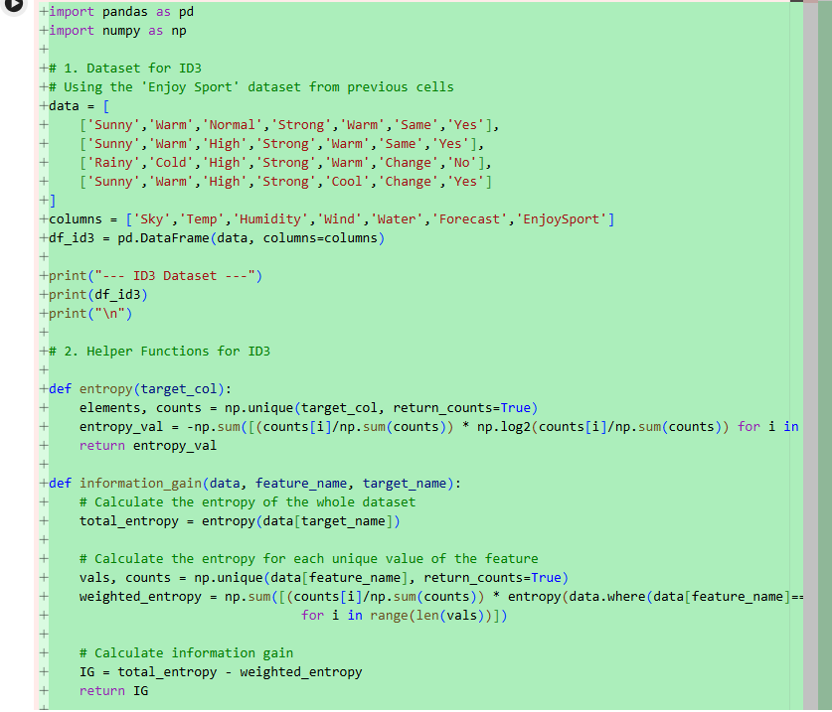

Output

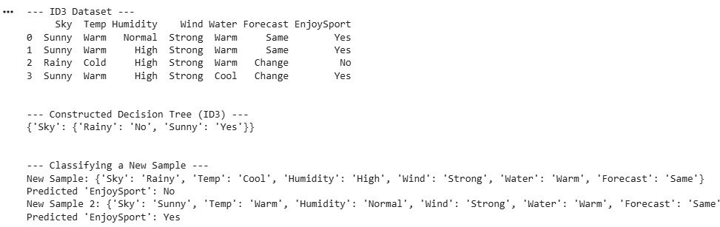

Result
Decision Tree classifier successfully classified the new sample.

Experiment 4: Artificial Neural Network using Backpropagation

Aim
To implement Artificial Neural Network using Backpropagation.

Procedure
- Load dataset.
- Normalize features.
- Train MLPClassifier.
- Predict output.
Program

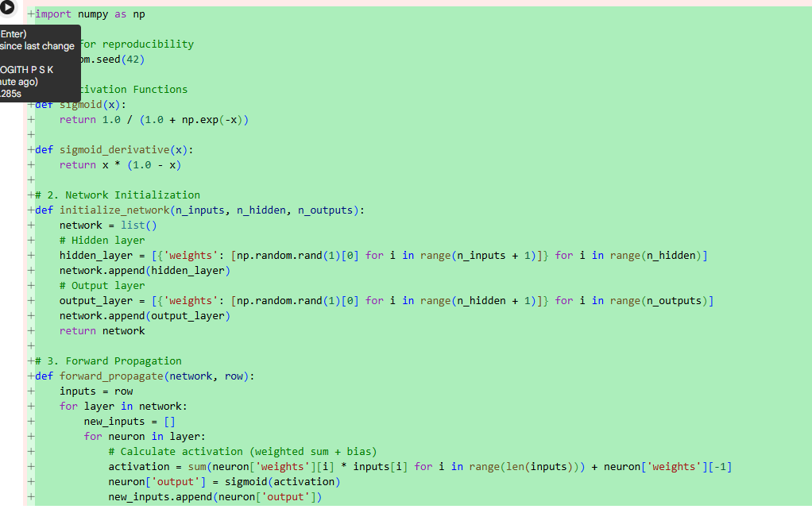

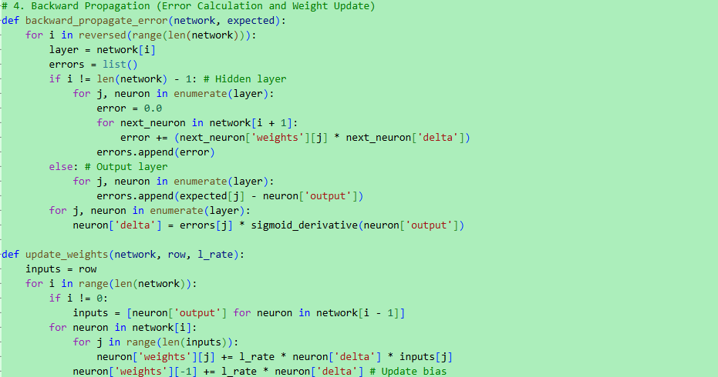

Output

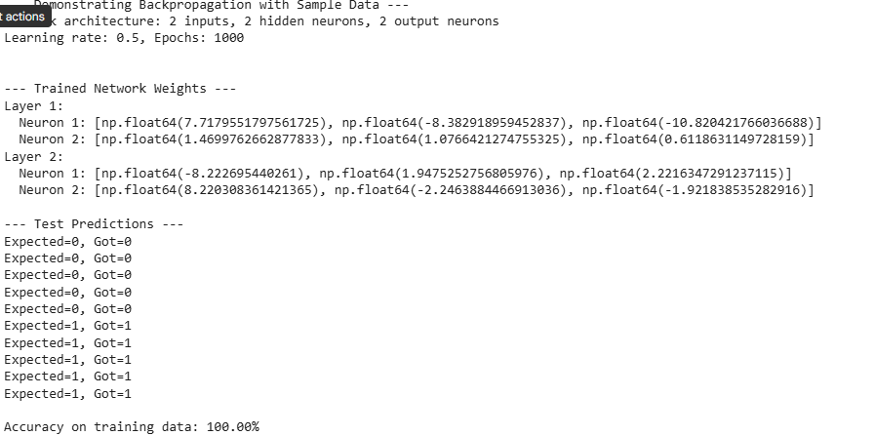

Result
Artificial Neural Network achieved good classification accuracy.

Experiment 5: K-Nearest Neighbour (KNN)

Aim
To implement KNN algorithm.

Procedure
- Load dataset.
- Split dataset.
- Train KNN.
- Predict.
- Calculate accuracy.

Program

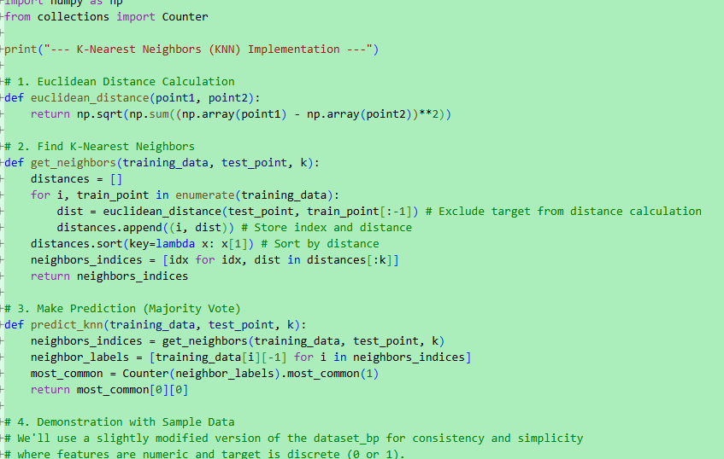

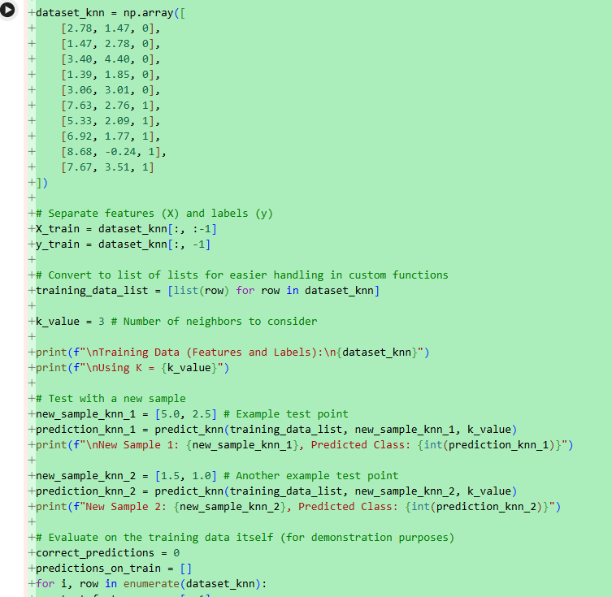

Output

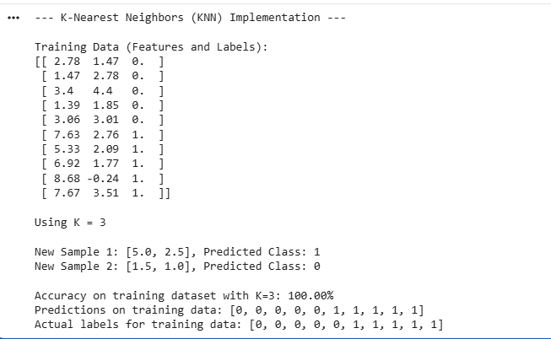

Result
KNN classifier classified the samples with high accuracy.

Experiment 6: Naive Bayes

Aim
To implement Naive Bayes classifier.

Procedure
- Load dataset.
- Train Gaussian Naive Bayes.
- Predict.
- Display confusion matrix and accuracy.

Program
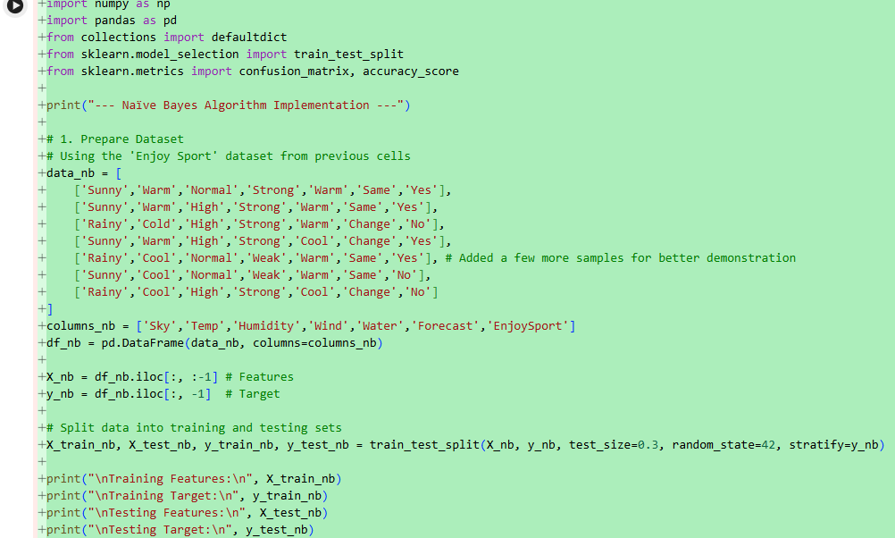
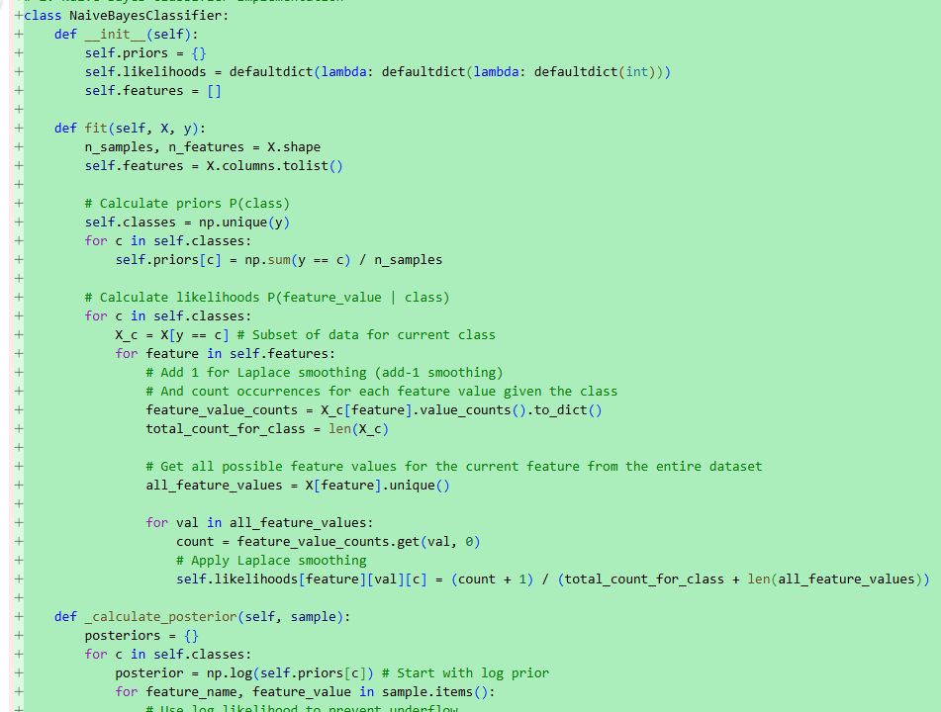

Output
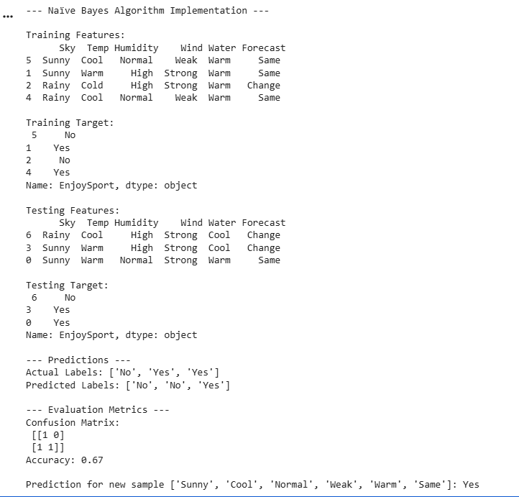

Result
Naive Bayes classifier successfully classified the test data with good accuracy

Experiment 7: Logistic Regression

Aim
To implement Logistic Regression.

Procedure
- Load dataset.
- Split dataset.
- Train Logistic Regression.
- Predict.
- Calculate accuracy.

Program

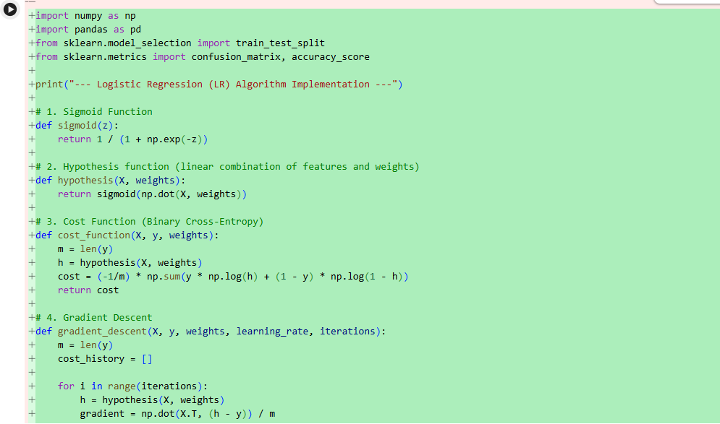

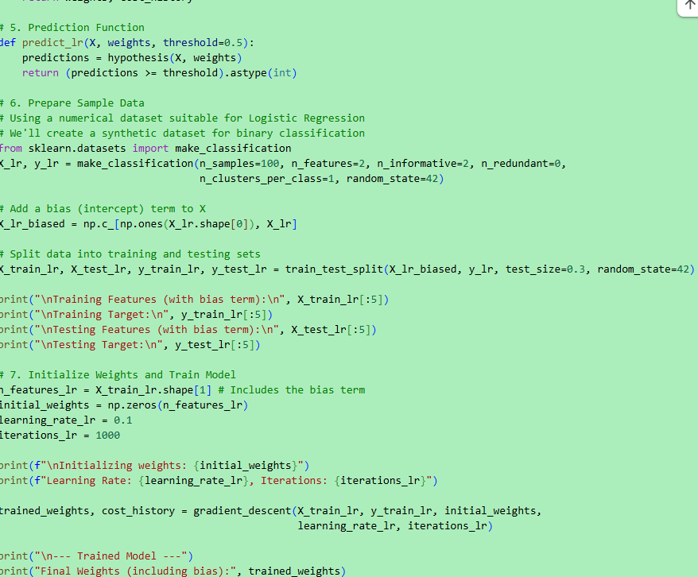

Output

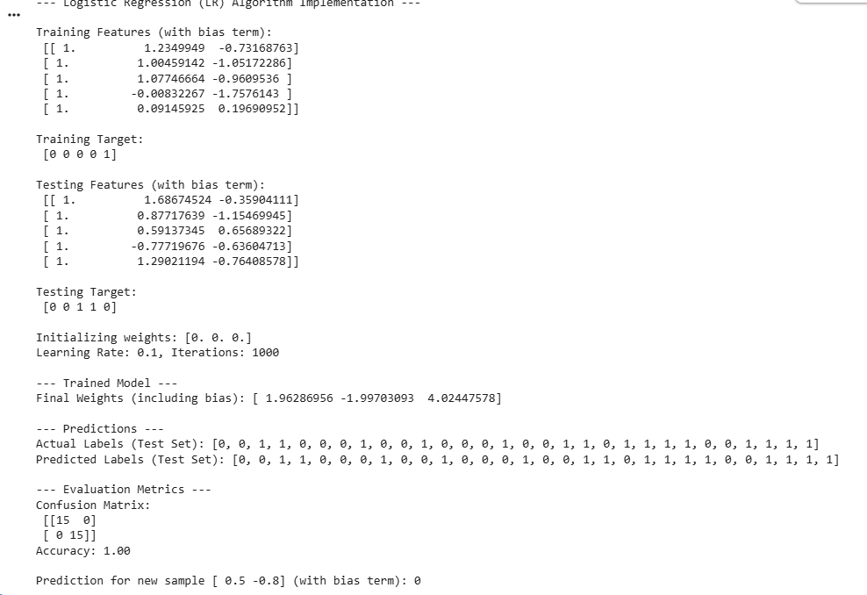

Result
Linear Regression predicted continuous values with low mean squared error.

Experiment 9: Linear vs Polynomial Regression

Aim
To compare Linear and Polynomial Regression.

Procedure
- Load dataset.
- Train Linear Regression.
- Convert features into Polynomial Features.
- Train Polynomial Regression.
- Compare Mean Squared Errors.

Program

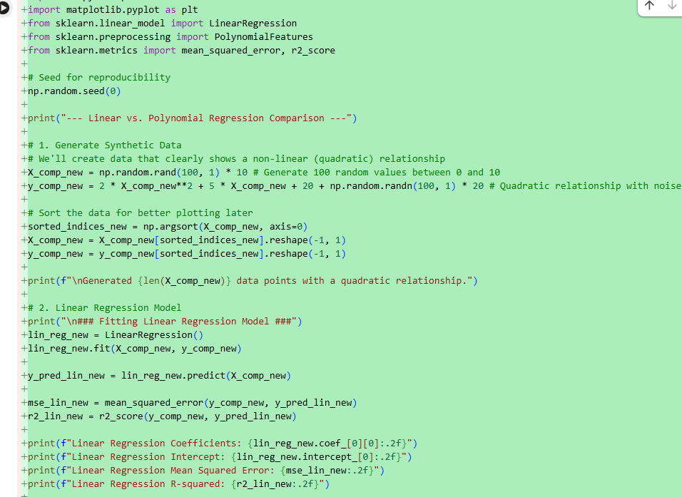

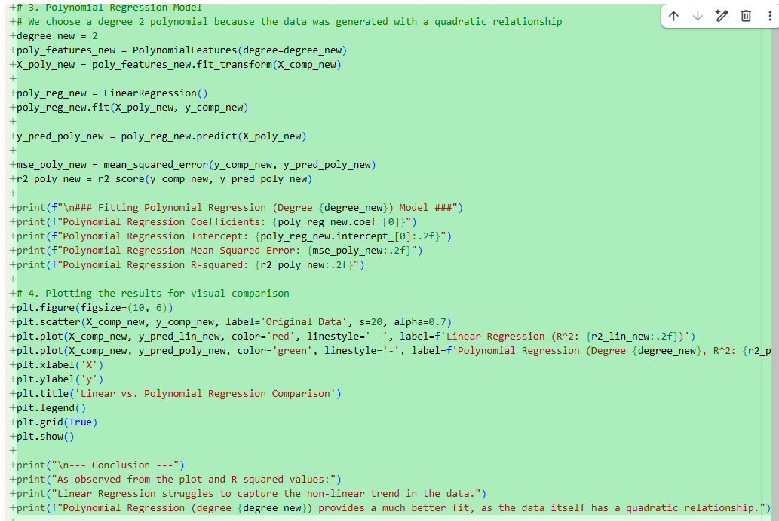

Output

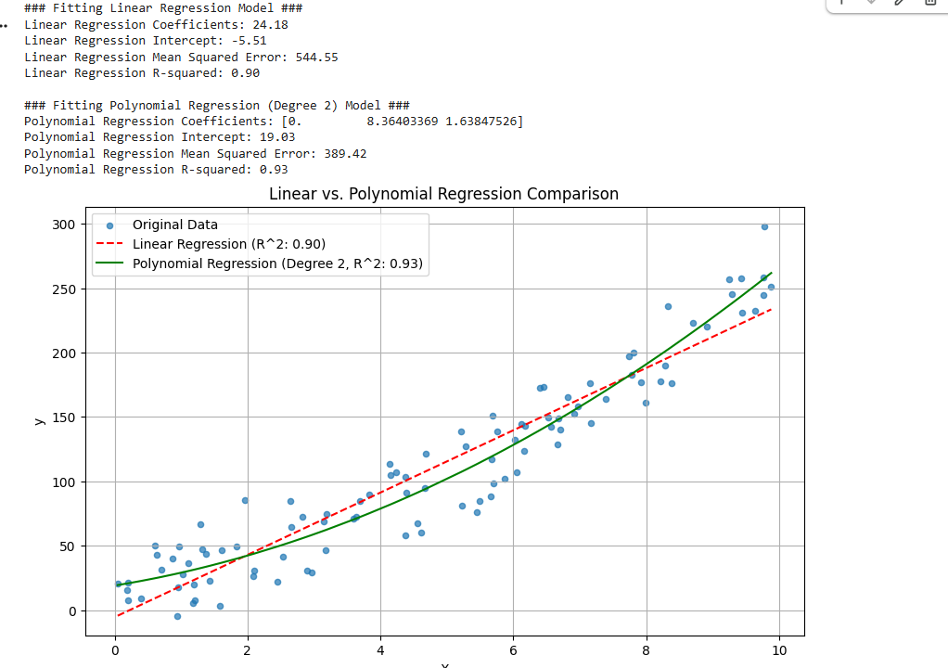

Result
Polynomial Regression produced a lower Mean Squared Error than Linear Regression for nonlinear data.

Experiment 10: Expectation Maximization (EM) Algorithm

Aim
To implement the Expectation Maximization Algorithm using Gaussian Mixture Model.

Procedure
- Load dataset.
- Train Gaussian Mixture Model.
- Predict clusters.
- Display cluster assignments.

Program

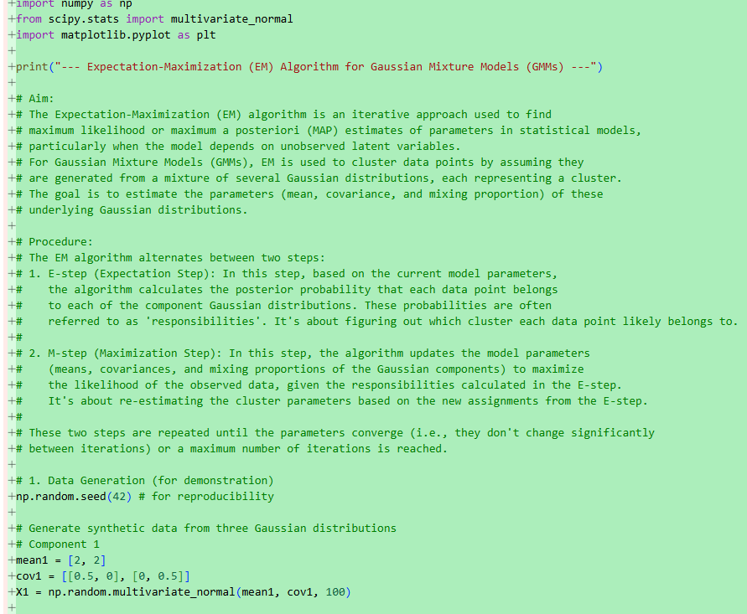

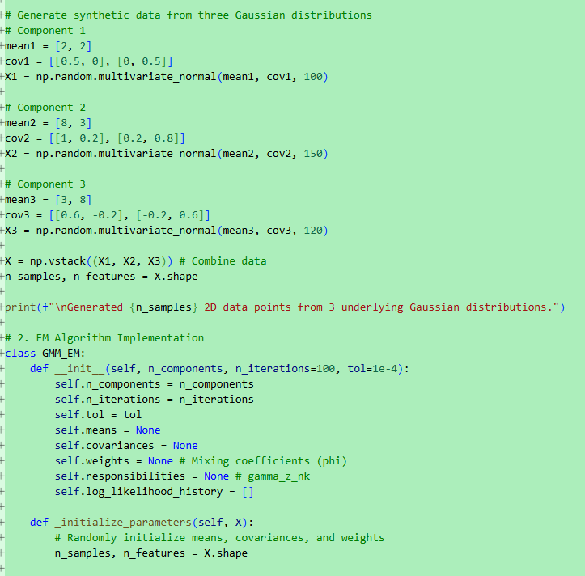

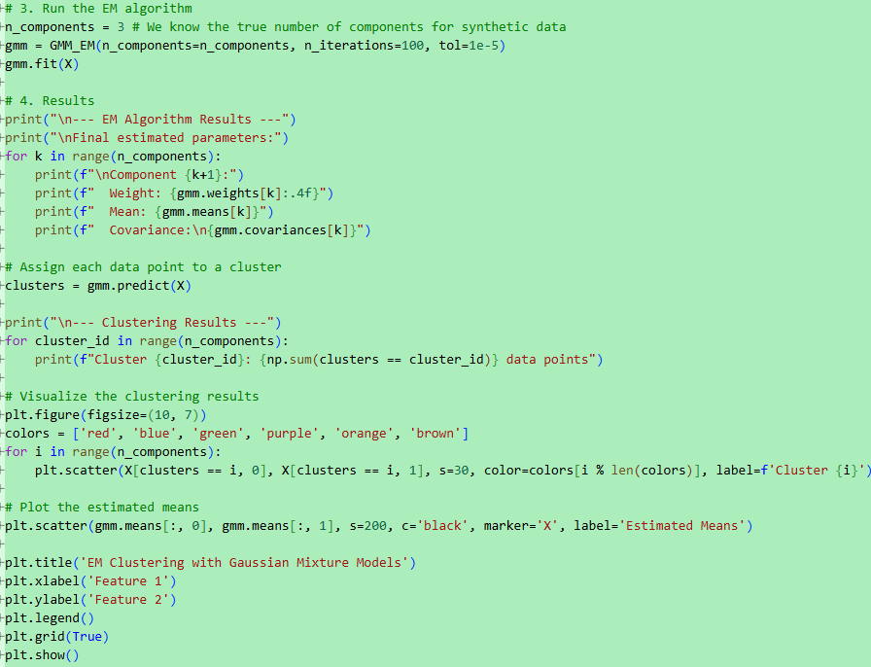

Output

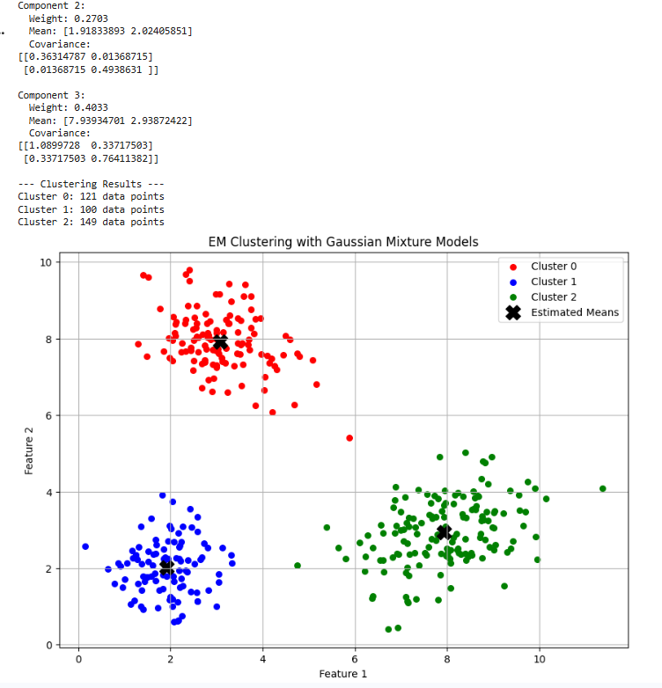

Result
The Expectation Maximization algorithm successfully clustered the dataset into different groups.

